Monday | Tuesday | Wednesday | Thursday | Friday
 |  |  | 1  French Toast Sticks  100% Fruit Juice  Chilled Fruit  Choice of Milk  Bundles: Breakfast Muffin | 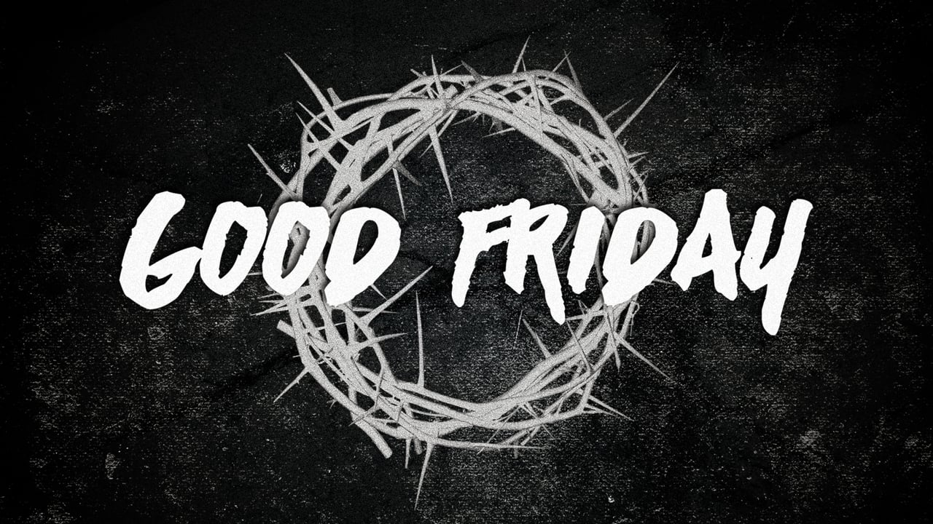  2  Esta foto de Autor desconocido está bajo licencia CC BY-NC-ND  No Classes
5  No Classes | 6  No Classes | 7  No Classes | 8  No Classes | 9  No Classes
12  Cereal Variety  Breakfast Graham  100% Fruit Juice  Chilled Fruit  Choice of Milk | 13  Pancakes w/Condiments  100% Fruit Juice  Chilled Fruit  Choice of Milk  Bundles: Breakfast Muffin | 14  Cereal Variety  Breakfast Graham  100% Fruit Juice  Chilled Fruit  Choice of Milk | 15  French Toast Sticks  100% Fruit Juice  Chilled Fruit  Choice of Milk  Bundles: Breakfast Muffin | 16  Cereal Variety  Breakfast Graham  100% Fruit Juice  Chilled Fruit  Choice of Milk
19  Cereal Variety  Breakfast Graham  100% Fruit Juice  Chilled Fruit  Choice of Milk | 20  Pancakes w/Condiments  100% Fruit Juice  Chilled Fruit  Choice of Milk  Bundles: Breakfast Muffin | 21  Cereal Variety  Breakfast Graham  100% Fruit Juice  Chilled Fruit  Choice of Milk | 22  French Toast Sticks  100% Fruit Juice  Chilled Fruit  Choice of Milk  Bundles: Breakfast Muffin | 23  Cereal Variety  Breakfast Graham  100% Fruit Juice  Chilled Fruit  Choice of Milk
26  Cereal Variety  Breakfast Graham  100% Fruit Juice  Chilled Fruit  Choice of Milk | 27  Pancakes w/Condiments  100% Fruit Juice  Chilled Fruit  Choice of Milk  Bundles: Breakfast Muffin | 28  Cereal Variety  Breakfast Graham  100% Fruit Juice  Chilled Fruit  Choice of Milk | 29  French Toast Sticks  100% Fruit Juice  Chilled Fruit  Choice of Milk  Bundles: Breakfast Muffin | 30  Cereal Variety  Breakfast Graham  100% Fruit Juice  Chilled Fruit  Choice of Milk
Breakfast Menu
St. Josaphat Parish School
2021

